**TASK 8 :PROTON VPN**

Description: In this practical you will learn how to install free VPN service,

VPNBook for Linux. For not getting into trouble by performing some activities we

need to hide our identity (spoofing), for that purpose we use VPNs, these will hide

our IP address and provide new IP address from their servers.

Tools: Linux operating system and VPNBook.

VPN establishes a virtual point-to-point connection which allows employees

in the organization to send or receive data across public networks as if the devices are

connected to the organization private network. VPNBook is one such software that

enables individuals to run VPN on their personal computer. VPNBook is a free open-

source VPN software.

● To download VPNBook, visit following website

**●** [**https://www.vpnbook.com/freevpn**](https://www.vpnbook.com/freevpn)

**Open terminal, goto Downloads directory and extract the VPN bundle we**

**downloaded using the unzip command as shown below.**



**We can list and see the ovpn files we extracted from from VPN bundle.**

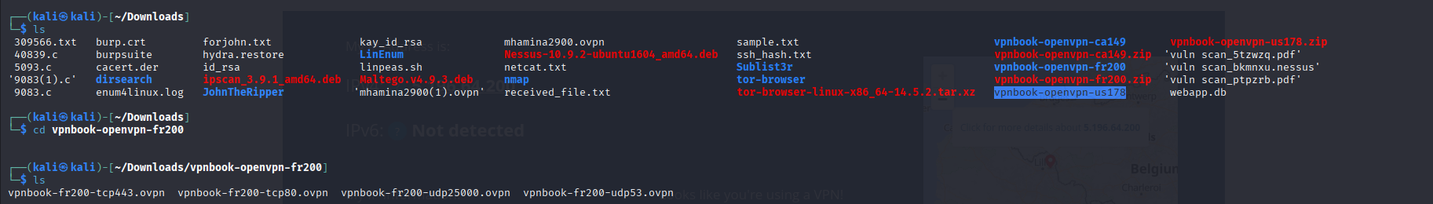

Select any ovpn (vpnbook-pl226-tcp443.ovpn) file and execute the

following command. We can get username and password from VPNBook website.

After executing the above command, wait until it displays Initialization

Sequence Completed message.

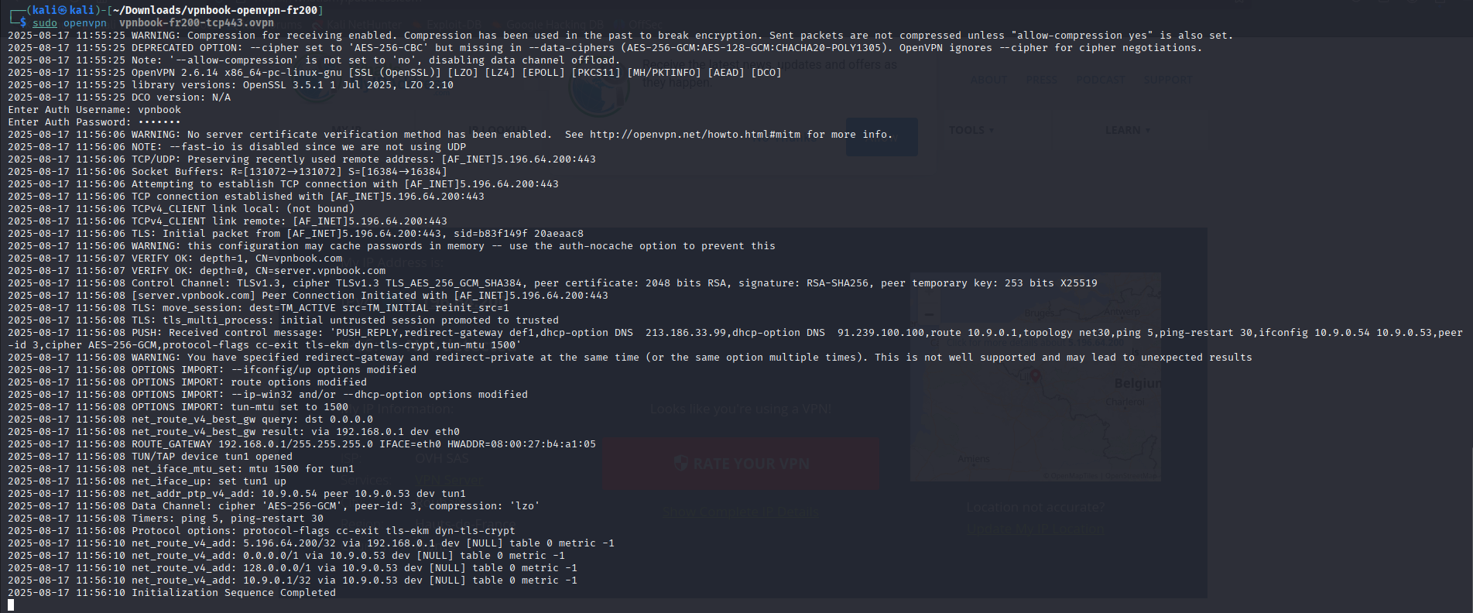

● Now we can use any browser to surf the internet anonymously (to confirm, you

can visit [www.whatismyipaddress.com](http://www.whatismyipaddress.com)).

